
International Journal of Computer Sciences and Engineering
Research Paper Vol.-6, Issue-9, Apr 2019 E-ISSN: 2347-2693

Door Unlocking Using Face Detection

Siddharth Suchak, Vismay Patil, Sahil Tambe
Dept of Information Technology, Vidyavardhini’s College of Engineering and Technology, Mumbai University, Mumbai, India

e-mail: sidsuchak@gmail.com, vismaypatil.patil@gmail.com, sahiltambe1996@gmail.com
Siddharth Suchak: sidsuchak@gmail.com, Tel.: +91 8698316883
Vismay Patil: vismaypatil.patil@gmail.com, Tel.: +91 9545836950
Sahil Tambe: sahiltambe1996@gmail.com, Tel.: +91 9768516820

Abstract— Most doors are controlled by persons with the use of keys, security cards, password or pattern to open the door. The aim of this paper is to help users for improvement of the door security of sensitive locations by using face detection and recognition. Face is a complex multidimensional structure and needs good computing techniques for detection and recognition. This paper is comprised mainly of three subsystems: namely face detection, face recognition and automatic door access control. Face detection is the process of detecting the region of face in an image. The face is detected by using the viola jones method and face recognition is implemented by using the Principal Component Analysis (PCA). Face Recognition based on PCA is generally referred to as the use of Eigen faces.If a face is recognized, it is known, else it is unknown. The door will open automatically for the known person due to the command of the micro-controller. On the other hand, alarm will ring for the unknown person. Since PCA reduces the dimensions of face images without losing important features, facial images for many persons can be stored in the database. Although many training images are used, computational eﬃciency cannot be decreased signiﬁcantly. Therefore, face recognition using PCA can be more useful for door security system than other face recognition schemes. This paper investigates the accuracy and eﬀectiveness of the face detection and recognition algorithms using OpenCV and Python computer language. The adaboost algorithm is used for face detection and PCA algorithm is used for face recognition. This paper also investigates the robustness of the face recognition system when an unknown person is being detected, wherein the system will send an email to the owner of the system using SMTP . The door lock can also be accessed remotely from any part of the world by using a Dropbox account. Keywords: Recognition, Detection, OpenCV,, Adaboost , PCA , SMTP , Viola-jones face detection method, ,Eigenvector, Covariance, Euclidean distance, Eigenface, micro-controller.

Keywords— Face, OpenCV, Eigen.

Introduction
Human beings are recognized by their unique facial characteristics. In the face recognition approach, a given face is compared with the faces stored in the database in order to identify the person. The purpose is to ﬁnd a face in the database, which has the highest similarity with the given face. In the ﬁeld of biometrics, facial recognition technology is one of the fastest growing ﬁelds. The recent interest in face recognition can be attributed to the increase of commercial interest and the development of feasible technologies to support the development of face recognition. Major areas of commercial interest include biometric, law enforcement and surveillance, human-computer interaction, multimedia management (for example, automatic tagging of a particular individual within a collection of digital photographs) smart cards, passport check, Criminal investigations, access control. However, face detection is more challenging because of some unstable characteristics, for example, glasses and beard will impact the detecting eﬀectiveness. Moreover, diﬀerent kinds and angles of lighting will make detecting face generate uneven brightness on the face, which will have inﬂuence on the detection process. To overcome these problems, the system used adaboost algorithm implemented using Haar classiﬁers for face detection and PCA algorithm for face recognition implemented using face recognizer function of OpenCV. Rest of the paper is organized as follows: Nowadays, automatic personal identiﬁcation in access control has become popular by using biometrics data instead of using cards, passwords or pattern. Most of the biometrics data have to be collected by using special hardware such as ﬁngerprint scanner, palm print scanner,DNA analyzer. And, the target objects have to touch with the required hardware in the stage of data collection. The advantage of this system is that face recognition does not require to be touched with any hardware. Face is detected automatically by using face detection technique and the entire face recognition is completed without touching with any hardware. Face detection is the ﬁrst step of the face recognition system. The performance of the entire face recognition system is inﬂuenced by the reliability of the face detection. By using face detection, it can identify only the facial part of an image regardless of the background of this image. In this system, Viola-Jones face detection method is used. Viola-Jonesrescale the detector instead of the input image andrun the detector many times through the image each time with a diﬀerent size. Viola-Jones have devised a scale invariant detector that requires the same number of calculations whatever the size. This detector isconstructed using a so-called integral image and some simple rectangular features reminiscent of Haar wavelets [1]. Face recognition commonly includes featureextraction, feature reduction and recognition or classiﬁcation. PCA is an eﬀective feature extraction method based on face as a global feature. It reduces the dimension of images eﬀectively and holds the primary information at the same time. In this paper, face recognition system is implemented using PCA algorithm. Recognition or classiﬁcation is done by the measure method such as Euclidean distance, which is used to classify the feature of images present in the database and test image.

Related Work
References used in this paper plays a vital role. The papers referred are combined and using some extra information the paper is published. Refer the References section in this paper further details.

Methodology
In this era of image processing, digital processing and neural networks why not make a real time intelligent device. Then after analysing all of this as our anime character who can feel the vibrations, we could use sound, thus a smart device could be possible. Researching on this more, we found lot of material on image processing, face reorganization, obstacle detection and OCR. As we wanted to make a portable device we thought of Arduino UNO for our processing purpose. Making an eﬃcient smart device.
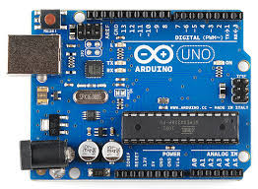
Fig 1. Arduino

Results and Discussion
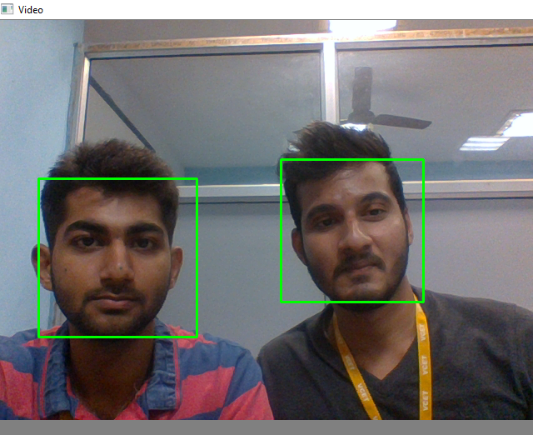
Fig 2. Detection of Faces
We have divided our project into small modules. As the project implementation is done with respect to those modules. We further wish to test all of these modules and also integrate them to one. So as to make the ﬁnal output as sound. We also wish to increase the accuracy and quality of speech. To detect the face and accordingly the speech should interpret the face details. The research for face detection using Arduino is in process. We have to integrate all the modules in Arduino and then we will try to add other features. Also, a module to calculate the size of face is needed. We also intend to do testing in the next semester. Real time testing with all possible inputs to make our device more accurate and more feasible with real time users.

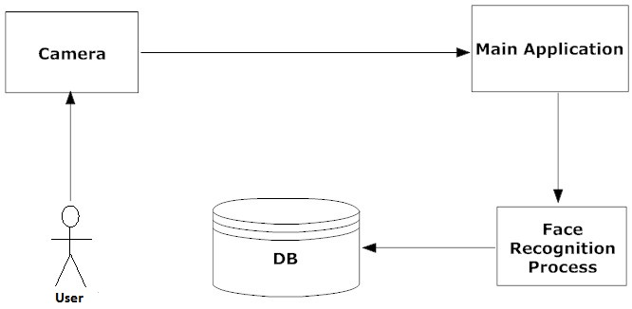
Fig 3. Block Diagram

Conclusion and Future Scope
The home automation using Internet of Things has been experimentally proven to work satisfactorily by connecting simple appliances to it and the appliances were successfully controlled remotely through internet. The designed system not only monitors the sensor data, like temperature, gas, light, motion sensors, but also actuates a process according to the requirement, for example switching on the light when it gets dark. It also stores the sensor parameters in the cloud (Gmail) in a timely manner. This will help the user to analyze the condition of various parameters in the home anytime anywhere. In this work we performed we are able to develop a system to evaluate the face detection and face recognition. To speed up the process of face detection we used Viola-Jones detection algorithm. The database created is used as a source for the Eigen faces and the input image is matched over the mean Image in Eigen space. As in PCA based face recognition, increasing the number of faces increases the recognition rate but the recognition rate saturates after a denite sum of increase in Eigen value. Increasing the images in the database increases the recognition rate however noisy images decrease the recognition accuracy.

ACKNOWLEDGEMENT
We take this opportunity to express our profound gratitude and deep regards to Head of Department Dr. Ashish Vanmali and our guide Prof. Archana Ekbote for their exemplary guidance, monitoring and constant encouragement throughout the course of this project. The blessing, help and guidance given by them from time to time shall carry us a long way in the journey of life on which we are about to embark. We also take this opportunity to express a deep sense of gratitude to the Teaching and Non-Teaching staﬀ of Information Technology Department, for their cordial support, valuable information and guidance, which helped us in completing this task through various stages. We would like to thank SentDex for his outstanding videos and clear explanation. We would recommend referring his YouTube channel for learning python and neural networks.

References
[1] Paul Viola, Michael J.Jones, Robust Real-Time Face Detection.
[2] Bhabatosh Chanda and DwijestDuttaMajumder, 2002, Digital ImageProcessing and Analysis.
[3] Nicholas D., Darrell B., Somsak S., Home Automation using Cloud Network and Mobile Devices, IEEE Southeastcon 2012, Proceedings of IEEE.
[4] Inderpreet Kaur, Microcontroller Based Home Automation System With Security at IJACSA) International Journal of Advanced Computer Science and Applications, Vol. 1, No. 6, December 2010.

